EXP 12
Aim
To perform perspective transformation on an image.
Procedure
- Import OpenCV and NumPy.
- Read the image.
- Define source and destination points.
- Compute the perspective matrix.
- Display the transformed image.
Code
import cv2
import numpy as np
img = cv2.imread("image1.png")
rows, cols = img.shape[:2]
pts1 = np.float32([[50,50],[300,50],[50,300],[300,300]])
pts2 = np.float32([[0,0],[300,0],[100,300],[250,300]])
M = cv2.getPerspectiveTransform(pts1, pts2)
result = cv2.warpPerspective(img, M, (cols, rows))
cv2.imshow("Original", img)
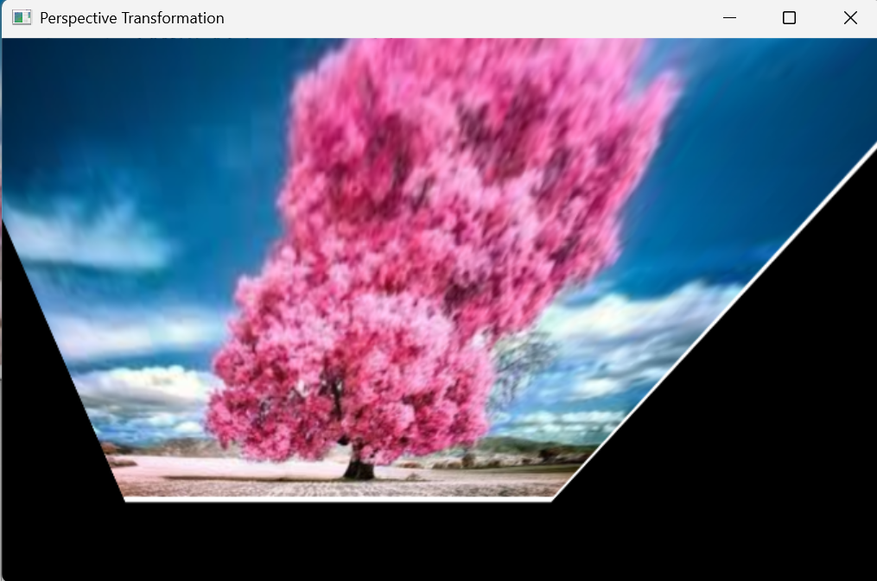
cv2.imshow("Perspective Image", result)
cv2.waitKey(0)
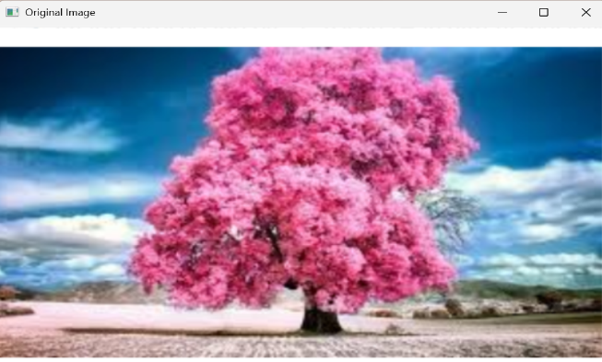
cv2.destroyAllWindows()

